The Trench  Award 2026 | 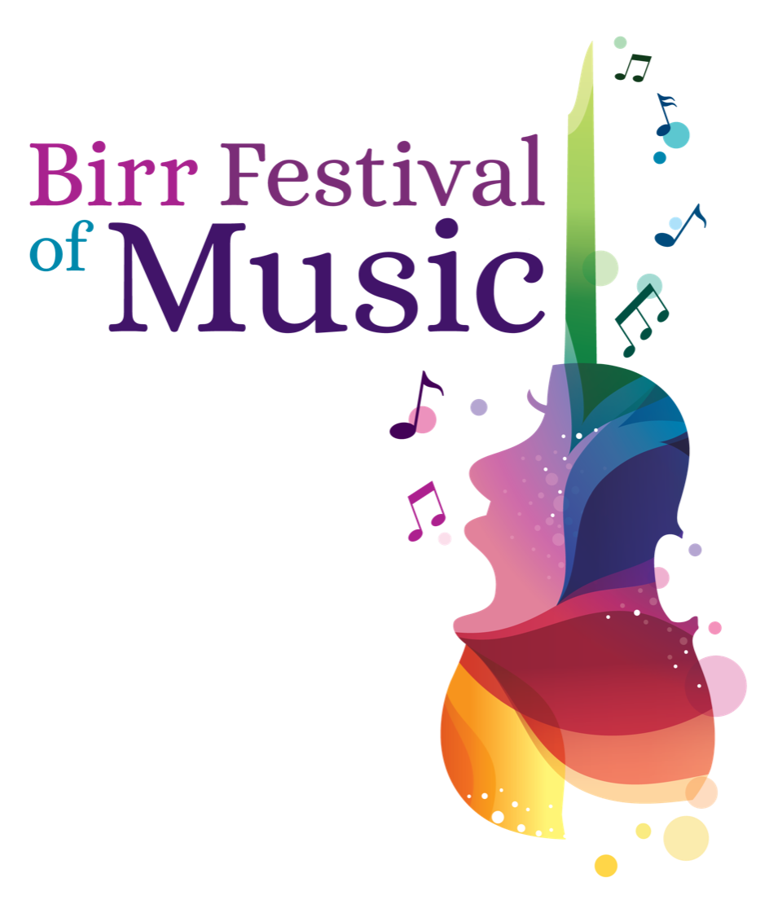

Applications are invited from emerging singers and instrumentalists who are pursuing a career in professional performance in classical music.

The Trench Award aims to assist an emerging singer or instrumentalist in developing their professional career through further study at home or abroad. The bursary will be awarded to a student attending, or having been offered a confirmed place at a University/Conservatoire/Young Artist Programme/other specialist music institute undertaking classical music studies, either instrumental or vocal, in pursuit of a career in professional performance.

Six finalists will be invited to attend Birr Festival of Music from Friday 1 May - Monday 4 May 2026, and to perform a 15-minute programme at The Trench Award Gala Concert at Birr Theatre & Arts Centre, Birr, Co. Offaly on Sunday 3 May 2026 when The Trench Award and other bursaries will be awarded by an international selection panel.

Eligibility
Please read the conditions carefully. Applications not meeting the criteria below will not be considered.

Applicants must be from the general Midlands/Mid-west region of Ireland. While there is no upper age limit, applicants should be enrolled in an undergraduate or postgraduate programme in Music Performance, participating in a Young Artist Programme, or less than two years of completing their studies. As the purpose and priorities of the award is to help artists develop their craft, applicants should not be undertaking a significant level of professional work and should be very clearly identifiable as ‘emerging’ artists.

Application form and further information available from www.birrfestivalofmusic.com or by request from thetrenchaward@gmail.com.
Deadline for receipt of application: Thursday 19 February 2026, 3pm

Important Dates

Thursday 19 February: Application Deadline
Thursday 12 March: Applicants will be notified
Friday 1 May – Monday 4 May: Birr Festival of Music
Sunday 3 May: The Trench Award Gala Concert

For further information contact: Maureen de Forge 087 283 6675 thetrenchaward@gmail.com

The Trench Award 2026

Julia & Patrick Trench
The late Julia & Patrick Trench were noted for their musical evenings at Sopwell Hall, Ballingarry in North Tipperary. Patrick played flute, harp and organ, Julia played piano and organ. Julia Trench, who died in 2007, designated that the residue of her estate be used to create a Trust Fund to support educational, cultural, religious and community projects. Thus, the JVM Trench Trust was established and has since been supporting appropriate projects, mainly in the Midlands of Ireland. Julia Trench was one of the many generous benefactors involved in the establishment of Birr Theatre & Arts Centre in the mid-1990s.

Further Information
- The Trench Award is €5000. Further bursaries, to the value of €5000 may be awarded including the Birr Lions Club Bursary, the Canto al Serchio Prize (for voice), the Connolly Award (for voice), the Lumcloon Energy Award (for instrument) and an Audience Choice prize.
- Applications are invited from students attending, or having been offered a confirmed place at, a ​​University/Conservatoire/Young Artist Programme/specialist music establishment undertaking classical music studies, either instrumental or vocal, in pursuit of a career in professional performance.
- Applicants must be from the general Midlands/Mid-West region of Ireland.
- Previous winners of The Trench Award may not apply.
- Application forms are available to download on www.birrfestivalofmusic.com or by request from thetrenchaward@gmail.com.
- Applicants are requested to complete an Application Form and return it with video recording (MP4) of two contrasting pieces and a high-resolution headshot (at least 1MB) to thetrenchaward@gmail.com by Thursday 19 February 2026, 3pm. ** Please see note on submitting video files on the final page of this document.
- Successful applicants will be notified by Thursday 12 March 2026. Finalists will perform a 15-minute programme at Birr Theatre & Arts Centre on Sunday 3 May 2026 at 7.30pm.
- The 15-minute programme can be of the applicant's choice and should include a variety of styles. Awards will take into account not only this 15-minute performance, but also interviews, future plans and use of bursaries.
- Successful applicants will have 30 minutes rehearsal time with the official accompanist.
- Successful applicants must provide a copy of all music programme choices by email no later than Thursday 2 April 2026.
- Award recipient(s) are required to acknowledge ‘The Trench Award’ in programme biographies and CVs.
- The Trench Award accompanist – Dearbhla Brosnan.

The Trench Award 2026
APPLICATION FORM
Full Name:
Age & Date of Birth:
Address
(While at college):

Address
(Home):

Email Address:

Phone Number:

Instrument /
Voice type:

Course Title and Year:

Name of current University/Music Institution/Young Artist Programme:
Name of proposed
University/Music Institution/Young Artist Programme:

Music Educational Details to date to include examinations:
Year | Awarding Body | Results (if available)
(insert more rows if required)

Are you in receipt of any other bursaries, awards or scholarships, please specify:

Professional Engagements (if applicable) – Past and Future:

Name and contact details of referee, eg: Instrumental/Vocal Teacher; Head of Music or Department at University/College/Institute.
Name | Contact Details

Music Programme - 15 minutes - Please outline proposed choice of repertoire. (Some changes may be made at a later stage)

Please state what you hope to achieve through your continued training and why you believe you should be awarded this bursary (max 200 words)

Biography (100-150 words)

Please give details of your Midland/ Mid-West connection if presently based elsewhere.

Where did you hear about The Trench Award?

Please submit an MP4 video recording of two contrasting pieces and a high-resolution headshot (at least 1MB in jpeg or PNG format).
*Studio quality recording is NOT required. Please use whatever equipment you have already e.g. phone.
* When submitting your MP4 video recordings, these can be very large files and it may not be possible to attach directly to your application email. Instead, these files can be shared with us via We Transfer or by sharing links to Google Drive, Dropbox etc. If sharing via We Transfer, please indicate this in your application email. If you are sharing direct links via Google Drive, Dropbox etc, please include these in the body of your application email and ensure that you have given the correct access for the Judging Panel to open these and download them for appraising your application.

Check List
- Completed application form (.doc or .docx format only)
- High-Res Headshot (must be at least 1MB and 300dpi)
- MP4 video recordings
Applications should be e-mailed to thetrenchaward@gmail.com

Deadline for receipt of application is Thursday 19 February 2026, 3pm

